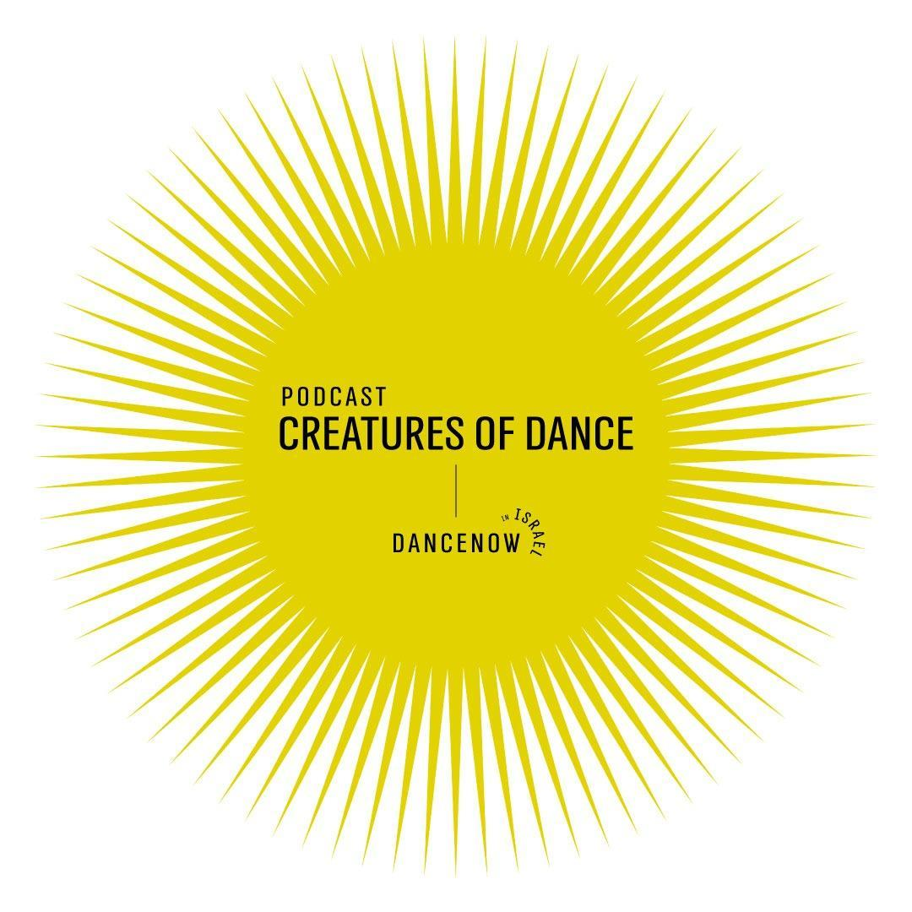
CREATURES OF DANCE
A Podcast on Contemporary Dance in Israel
Yali Nativ & Iris Lana

https://www.hayotmahol.com/home

Look at Yourselves!

Israeli identity and politics in
Ohad Naharin’s 2019 (2019)
Batsheva Dance Company

Episode 2

With
Dina Aldor Executive Director, Batsheva Dance Company
Eri Nakamura Dancer, Batsheva Dance Company, and costume designer
Yoni Simon Dancer, Batsheva Dance Company
Ran Brown Head of the dance program at Telma Yellin High School for the Arts, independent dance researcher, and dance critic for Haaretz newspaper

Recorded in 2020
Transcription: Guy Dolev
Translation from Hebrew: Michal Shalev

YALI: What are the connections between Ohad Naharin’s Kyr from 1990 and his latest work, 2019? 2019 sums up three decades of work, some more political than others, but 2019, like Kyr, expresses a well-defined, coherent political stance. Both of these works cast a painful, disillusioned look at their contemporary reality, back then and now. And 2019, like Kyr, has clear markers and representations of Israeliness and Israeli identity, primarily in its soundtrack.
The first song, which caught me by surprise, the song that opens the show, is "Mishak Klafim" - which means "Card Game" in English by Yirmi Kadoshi, from the album "Mabat Ko'ev" (Painful Look) by Moshe Cohen, who was the prince of Mizrahi-Middle-Eastern music in Israel in the 90s. He sings, in a Mediterranean trill:
"In dark streets we lost our paths".
In the dark streets, we lost our paths
Far away from our loved ones, we feel lonely
People hurt us by closing doors
Chasing us away, how have we sinned, oh Lord
Everybody calls us the children of embitterment
They keep rejecting us because daddy played the cards.
At the climax of the show, Naharin reads an excerpt from "You, Me and the Next War" by Israeli playwright and theater director Hanoch Levin from 1968, a moment we will discuss in detail later on.
The work also includes a song by the famous Lebanese singer Feiruz, as well as music by a Japanese pop singer, and a Rap-Trap mix VPM-style by a DJ from Abu Dhabi. The dancers sing the traditional Jewish song "Hine Ma Tov", and a popular nursery rhyme "LaKova Sheli Shalosh Pinot" ( my hat with three corners). And the lyrics of the ultra-Israeli song from the 70s, "Bashana Haba'a" (Next Year), by Ehud Manor and Nurit Hirsch, are projected onto the wall, and set to the sound of an accordion.

HOST: You are listening to Creatures of Dance – a podcast on Dance in Israel. Creatures of Dance with Yali Nativ and Iris Lana. And in this episode: Look at Yourselves - Israeli identity and politics in Ohad Naharin’s 2019 for the Batsheva Dance Company.
Dr. Yali Nativ teaches and researches dance in sociological and anthropological contexts. She is a senior lecturer at ASA, the Academic College of Society and the Arts. She writes about art education, sociology of the body, movement and performance, and about dance and Israeli society. Her current research examines ageing professional dancers. Yali is the chairperson of the Israeli Choreographers Association
Iris Lana is a dance researcher and a lecturer at the Jerusalem Academy for Music and Dance. She served as the director of Batsheva Dance Company’s Archive Project and was the director of the digital dance collections project at the Israeli National Library. Iris is the CEO of Diver Festival.
The hosts and interviewees in this podcast are played by actors.

Iris: 2019, Ohad Naharin's latest work, premiered in December 2019. A 75-minute show on a long and narrow stage, designed for this work in Varda Studio at the Batsheva facility, where the company usually practices. The audience sits close on both sides of the stage. This unique setting has many implications, some of them administrative. For example, the audience is limited to exactly 270 people, and that is probably why two consecutive shows were held each night.

iris: Dina Aldor, Batsheva's Executive Director, about the production challenges of 2019 in Varda Studio.

Dina: So, there you have it, we made 2019, there was nothing routine about it, it was a production challenge, an audience management challenge. When you embark on a process such as this, you don't know where you are headed, you don't know there will be a 2019 at the end. It's a big question mark. Varda Studio, which is the Varda Hall, is a venue like any other, with a business license. It became the Varda Hall because of my predecessors, Naomi Fortis and Hadassa Hashani, who were the chairpersons of Batsheva's administrative board for many years. And of course, with Ohad's encouragement and push and initiative to turn the company's studio, which is a great studio, into a venue that could enable non-standard forms of seating, various configurations. And Ohad has, in his volume of works, several works that are meant for this kind of space, like Mamootot from 2003, in which you sit in a square, The Hole from 2013, and now 2019. Some of Ohad's research is about exploring the totalized experience of performers and audience in a very specific physical space. Even Venezuela, from 2017, which is performed traditionally in a proscenium theater, examines the duplication of choreography; but his research of physical space is also very significant. So, making a comment on our current times (in quarantine due to the Coronavirus), about the videos we can watch while lying on our sofas - that is not the point, of course. The point is the physical experience, a total physical experience where you sit in a specific kind of space, and the artists create a universe for you. The universe of The Hole is a specific kind of universe, and the universe of 2019 is a specific universe with its own logic. Anyone entering the space of Mamootot, in which we sit in the light, like the performers, we are close to the performers, or Furo which is a replica of a Japanese public bath, the Hole with its octagonal stage, and 2019, it is clear that we enter and the space itself already defines us, directs us as participants in the experience. It is not watching, it is embodying a physical experience that is highly characterized, defined, and refined, where things are thought through. It is very different from watching a video.

Iris: Shortly after the beginning of the piece, when the two screens hiding the stage open, the audience sitting on one side of the stage is surprised to discover others sitting on the other side.

Iris: We asked Ran Brown, dance researcher and critic for Haaretz newspaper, about how he wrote about 2019.

Ran Brown: In the 1960s, American writer and critic Susan Sontag claimed that the purpose of writing about art was to make the work it was writing about more real to the readers. Similarly, I also think of my writing as some sort of amplifier; I really imagine it as some sort of megaphone. What can this writing do, what does it recognize in the work of art that is essential, and how can it resonate? What can the writing clarify for the spectators? Another aspect that is important to me is thinking about how a specific work asks me to write about it, in a way that will be different from writing about other works. What is the right rhetorical expression that matches this specific work? In this case of Naharin’s 2019, it was the repetition of the phrase "look at yourselves" because I was thinking that this was the essential action that the work creates: it keeps asking the audience to look at themselves. It demands they do so. It requires them to do so. It pleads with them to constantly do so. This plea is apparent from the first moment of the show, when people in the audience find themselves gazing at each other, as they are seated on both sides of the stage, while there are no dancers yet.

It becomes even more present once, at a certain moment of the performance, the dancers leave the stage and lie down on some of the spectators, so that nothing is happening except people in the audience watching other people. And Naharin also grants us this introspection when he slows down the pace, when the dancers pace very repetitively, almost in a meditative state, across the stage, and we, the audience, have the possibility of reflecting on the current moment. Perhaps also to think about the metaphoric, not only the literal sense of "looking at ourselves": what the significance is in the context of national and cultural levels.
It could, for example, stem from our identification with - or maybe revulsion of - the soundtrack and the thoughts it evokes in us. The surprising use of the Arabic language in the opening moments of the piece immediately makes us, Jewish-Israeli audiences, think about all the instances in which we do not hear this language in our day to day reality; his use of Mediterranean music or old, nostalgic Israeli songs; and also, his use of other foreign languages – singing in Japanese or Arabic. It constantly made me think about this conflict between local and global, our aspirations to be " out there", which is also colored by a very specific "out there", not necessarily the "out there" that has roots in our local area."

Iris: Like Kyr, 2019 is also composed of various scenes, some of which include all dancers, others with smaller groups or solos. The movement language here is Gaga. Gaga is the daily practice method for Batsheva dancers, and it is worth expanding a little about this invention of Naharin's. It is an innovative movement language based on research that amplifies sensorial experience and imagination, enabling the use of internal images to find new and personal patterns of movement, beyond the known limits of coded dance. Gaga classes for the general public began in 2001; in 2002, it became the practice language of Batsheva dancers, and in 2003, the name Gaga was officially adopted. Naharin has continued to develop it over the last decades, and it has become popular in the dance world in Israel and major cities around the world, as well as becoming a dance practice for people who are not professional dancers. For those unfamiliar with the method, it is worth watching some of the multiple videos available on YouTube.

Iris: Let us return to 2019. The outfits, made by Eri Nakamura, a dancer in the company, are spectacular. Each dancer wears something different. The fabrics, colors, and cuts vary, and come from entirely different worlds; this is also true for the use of accessories, some of which were designed especially for the work. In parts of the performance, the dancers wear very high platform shoes from the world of Voguing clubs.

Iris: Eri Nakamura, a Batsheva dancer, costume and styling designer for 2019.

Eri Nakamura: I spent a lot of time in northern Israel while working, and the road passes through Arab towns. Each time I see the stores of wedding dresses, the dresses are bright, colorful, and shiny, and I always want to wear one of these. Listening to the music of 2019, I thought it could work. I thought: Costume-wise, this work should be like an Arab wedding. Of course, I have never been to an Arab wedding, and I do not know the tradition. This is entirely my fantasy, because, you know, I'm Japanese, I don't have a clue about what they are wearing, but this is what I imagined. I wanted to have many shiny, happy colors, something happy to dance with in this work.

About jewelry, I always liked wearing Jewelry. I also liked Ballet costumes and wanted to work with them. You know, in Ballet you have a tiara, earrings, glamour, and princesses. I was always looking for an opportunity to wear something like that. I thought it would be appropriate for the wedding party. I also decided there would be jewelry, but jewelry in dance needs to be made especially for dance, because of the sweat and the interaction with the lighting. I was looking for someone with knowledge about that and about what we were doing. I talked to Liron Etzion, a jewelry designer who works with Batsheva on costumes. I started working with her. She designed gorgeous white earrings and many rings, very unique items that create a unique feeling.

There is another designer, Keren Wolf, who is a good friend of mine. The jewelry she designs is more elegant, more romantic. And she contributed earrings that I liked, so that each dancer feels different. We couldn't afford to buy Jewelry for each dancer, and still I wanted it to be like I had imagined, so I decided to contribute the earrings I collected over the years, so it all became a very personal design for me.

Iris: Batsheva dancer Yoni Simon recounts the work process in 2019

Yoni Simon: We are onstage for most of the show, and the proximity between the audience and the dancers, which in this work is extremely close, creates a certain feeling of ""being in the moment"", a very strong alertness, which, to me, is the biggest challenge in this work, the mental challenge. From the beginning, it had an almost crying or post-crying feeling to it, a strong feeling of surrendering and letting go. Departing from a very physical feeling.

Sometimes, Ohad would come with a scene and a very detailed image of the moment, he already knew what he was aiming for, as if he had a certain vision. For example, the entrance, in the beginning, when we enter with our arms and hands outstretched, and invite the audience to enter our space. He would always use this image, I remember, like a tribal chief of a Bedouin tent who invites a group of people to enter the tent, to enter and eat, with outstretched arms and with a great sense of giving.

Iris: Ran Brown, dance researcher and critic for Ha’aretz newspaper.

Ran Brown: Naharin's choreography for the song LaKova Sheli Shalosh Pinot (my hat with three corners) is an excellent example of a choreographic mechanism that is simple and complex at the same time. It is also a good example of the general working mechanism of a theatrical image, its multi-layered structure, the simultaneity of a show onstage, which is very different from me writing or talking right now. My dependence on the linearity of time forces me to interpret things one after the other, but in a show, in that specific moment, all the information is laid down simultaneously. That is what gives that moment, and choreography in general, its power. The fact that things happen simultaneously.

What happens in that specific moment in the work is that, to the sound of a children's song, which is so familiar to us, the dancers sit and place their hands on their heads, in a manner resembling war prisoners more than children playing. Then they perform a series of complex movements, with other movements we know from the song, which is based on a mechanism of subtraction. This is also contrary to the choreographic act, which is usually an act of adding up, of doing. Choreography is a succession of movements adding up, and here we have an opposite mechanism of negation, of subtraction, which is also a mechanism of disappearance, of muting. Movements gradually disappear, and the dancers perform movements that indicate silencing. So this makes us think of censorship, and the political dimensions are creeping in. This is being echoed in other actions throughout the show, in which dancers are subtracted, withdraw from the group, so this is some recurring motif.

While writing my critique, I found another layer in the use of this song. It is a very popular nursery rhyme, and we perceive it as part of our Israeli culture, but when retracing some of its sources, we discover it is a folk song of German origins. This is interesting because this happens throughout the entire work. This mixture, or hybridity. It exists in the song itself and also in our culture.
We take the foundations of culture, which are composed of different sources, of Germany, of a certain folk song, or Voguing, a dance culture originally from New York, or the Middle East, here around us. And this is really how society works: it creates itself from a wide variety of sources, builds new things from what already exists.

Iris: In the first weeks of the show, in December 2019, there was a buzz, and suddenly you couldn't get tickets, then the company added shows, and tickets were snatched, and then one couldn't get tickets even for February, so they added more performances for March and June.

The data from Batsheva shows that in the short period between December 2019 and the middle of March 2020, there were more than 11,000 spectators in 50 shows. If COVID-19 didn't stop it all, there would have been 38 more shows until July, and the official premiere was scheduled to take place at the Montpellier festival in France in the fall, with six more performances. This is a surprising number of shows, some of which never took place, but it indicates an astounding success.

Back to Batsheva's General Director, Dina Aldor.

Dina: First of all, I think it is truly wonderful to have a canon. A canon provides context and historical background; it is extremely important to have a canon of dance works, and I think that all of us who work with dance, creators and dancemakers of all kinds, as well as researchers and producers, are aware of the canon, for example, Balanchine and Cunningham. There are certain works we see and say: these are canonical works. Now, by the way, when we watch so many productions online, such an abundance of content, all the archives spilling out their treasures, there are works that I watch and my heart starts pounding, and I say: Wow, this is Trisha Brown, there it is, there it is. Many of Ohad's works are canonical as well, people remember fragments of them, they have images of the stage, of certain moments, engraved in their memories.

I think there are periods in Ohad's work: pieces such as Sade 21 from 2014, Last Work from 2015, Venezuela, The Hole, and now 2019, are certainly canonical. Also, Hora from 2009. People in the world ask us: Oh, when will you remake this and that? We want to see this and that. 2019 will certainly be canonical.

Ran Brown: I don't know how many people know what Kyr is, but referring to the first episode of this podcast, Echad Mi Yodea became canonical because of what happened later, because of the way the work was used.
Dance researcher Mark Franko talks about the way a work of dance becomes political. One of the possibilities in which a work of dance becomes political, he says, does not depend on what is in the work itself, but on its context, the events taking place at the time, and how it fits into this game. Echad Mi Yodea entered this game at a very specific moment, and became a tool used by politicians, and later a means for people in the art world to defend the freedom of speech.
It is interesting to note that Echad Mi Yodea is also based on a mechanism of accumulation, of repetition. The song Echad Mi Yodea uses a mechanism of accumulation, adding up words and adding up movements, while the repetition I mentioned earlier, in HaKova Sheli in 2019, is a repetition based on subtraction.
Yet I think it is still too early for us to say whether 2019 will become such a canonical work. I see 2019 as sort of a wake-up call, and the question is whether it is a wake-up call that reality will show us that something here was true, and that reality corroborates it, or whether reality will disprove it, and that it was good that there was such a wake-up call. But it is too early to tell."

Iris: Let us describe one scene from the performance:

Suddenly, the dancers get off the stage. We have seen this in other works before, but then they take thick blankets, disperse between the rows of seats, and after they gently, wordlessly, ask for permission, they spread the blankets on our knees and carefully lie on top of them. Yes, on our knees. Everything becomes personal, physical, moving, intimidating, and surprising. What do we do? What am I supposed to do? This is what goes through my mind. And this is a very long scene, the presence of a body that is lying on top of me becomes amplified to an intimacy that is almost too much to bear. Hey! How is it possible that this bionic body I saw onstage only a minute ago, from a relatively safe distance, penetrates my personal space, lying on top of me with such vulnerability and totality? This body is tangible, it has weight, temperature, and length, and my body responds with alertness, then with a feeling of responsibility, and in constant bewilderment.

Yali: You know, and this happens towards the end of the show, when the sadness and pain had already sunk deep into my heart. I watched this performance three times, and when we reached this scene for the first time, I was shocked. When the dancers lie down in the audience's laps as if they’re going to sleep, one dancer remains in the center of the stage, lying on her side, as if she is also sleeping. And the text that is read is "You, me and the Next War" in Ohad Naharin's voice.

The first time I heard it, I was certain it was Rami Fortis, the musician; I simply did not recognize the voice. There was something metal-like, different from his familiar warm voice. And so, people sit in the audience, on both sides of the empty stage, looking at each other. And it is very interesting to see what happens to the ones the dancers lie on. Because I noticed that some of them, for example, were uncomfortable, and they did not know what to do with their hands and where to place them; some seemed very embarrassed, others were giggling, and very few, as far as I could see, dared to touch the dancers.

I must confess that the second time I watched the show, I wanted it to happen to me, that one of the dancers would come and lie on me. I even checked to see if there was a blanket before sitting down. I wanted to feel that on my body."
Yoni Simon (dancer): The truth is that I was worried, we had some concerns about the audience's reaction, and even, you know, if I am sweating, maybe I stink because I just danced and released energy, how they will take it; and this dialogue was always there, we tried it and we brought audiences to experiment as well as friends of the company. But the scene is very powerful. When the audience takes the weight of the dancers, which it had just seen onstage, it receives their weight, and it's a very powerful moment for me too, as a dancer. Approaching the audience is very difficult; it gives me a shudder when I suddenly come and penetrate their space, and I am sure they will accept that too. I pass that on to them and experience that moment with them, and it is very strong every time.

Iris: Towards the end of the show, we hear "You, Me and the Next War"", a song from Hanoch Levin's 1968 satirical cabaret, in the voice of Ohan Naharin (and I quote):

"When we're sleeping, we are three
You, me, and the next war."

"You, me and the Next War", written immediately after the Six Day War, was performed at the "Bar-Barim" club in Tel Aviv, after the Tzavta (theater) venue refused to host it. It was one of the first plays by the then-unknown playwright Levin. The media attacked him viciously. On July 18, 1969, Journalist Uri Keisari wrote in "Maariv" that Levin ""spits, degrades, mocks and humiliates". Also on "Maariv", journalist Nachman Ben Ami asks in an article titled "The Talent and the Failure”: "are we witnessing a sick ideology, a childish stupidity or an incurably complex mind?". Due to these reactions, the show was cancelled, and ever since, it is considered a pungent satire, or an outrageous scandal, depending on whom you ask.

In his piece 2019, Naharin reads the text in his voice, this is what he has to say at the end of the striking spectacle we have just witnessed. Thus, he places himself on Levin's side and reaffirms his opposition to the victory festival of joyous Israel after the Six-Day War. This implies that today, too, there is an urgent need to return to this text, in a nation that aligns itself almost unanimously with the positions announcing the next war.

Yali: After watching 2019, a good friend of mine wrote to me: "Yali, it was an unsettling experience for me… I still can’t let go of it… I don't even understand why. It never happened to me in dance."

Many of the people I know left the show wanting to watch it again. Feeling that they must watch it again. Why?

We tried to ask about 2019 similar questions to those we asked about Kyr in the first episode. For example, is it especially important? What makes people want to watch it again? For now, I can say that 2019 is a work of dance that, due to the circumstances, ended prematurely.

As we mentioned, the numbers indicate success and a great interest from the audience, but then it was put to a halt, like everything else was put to a halt, because of COVID-19.

I heard that in the last performances before the shutdowns, the Company made the decision not to have the dancers lie on the audience. They stayed onstage and they lay there.

So, we see how reality forced an unforeseen change on the choreography and defined what can and cannot be done. This leads us to two wider questions: one is the political significance of the work. Ran Brown mentioned Mark Franko earlier, who says that a work of dance becomes political when the circumstances in which it is created are political. In this sense, 2019 was created in a year when there were three, who knows, maybe four rounds of elections, a year in which Israeli society is more polarized and torn apart than ever, and there is no solution in sight.
When danced, 2019 maintains a painful look on the cultural-historic baggage of the nostalgic Israel of decades ago -- and also some sort of a warm and bubbly Mediterranean Israeliness.

But when dance works are not performed, they don't exist. Which brings me to the second question – the experience of 2019 still resonates in the minds and bodies of those who had a chance to watch it. But how relevant will it be when and if the world. We can say one thing for certain: Ohad Naharin's status has changed since 1990. He arrived at Batsheva as a young choreographer. Today, with an impressive arsenal of works, he has an international reputation that has evolved in parallel with the worldwide success of Israeli dance.

_________

Iris: We would like to thank the Batsheva Dance Company, Executive Director Dina Aldor, Deputy of Content and Communications Noa Ron, Director of Sound Department Dudy Bell, and the Batsheva Dance Company Archive. To our guests, Yoni Simon, Eri Nakamura, and Ran Brown. We thank Ido Kenan and Omer Senesh from Podcastico for the production and Sarah Holcman, Adi Drori, Nataly Fainstien, and Ido Kenan for the narration.

Music, by order of appearance:
"Mishak Klafim" – lyrics by Yoni Kadoshi. Music and singing by Moshe Cohen. From the album "Mabat Co'ev".
"Hine Ma Tov" – lyrics: book of Psalms; Music: traditional
"You, Me and the Next War" – Lyrics by Hanoch Levin, Music by Alex Kagan, performed by Gad Kaynar, Shifra Millstein and Bat-Sheva Zeisler.
"You, Me and the Next War" – Lyrics by Hanoch Levin; Arrangement and interpretation by Maxim Waratt
"LaShana Haba'a" – Lyrics by Ehud Manor; Music by Nurit Hirsch; Accordion by Uzi Rozenblat

You can read more about the content of this episode on our websit,e where you will also find images and links to relevant materials.

HOST: Check the podcast online.
Thanks to The Cultural Diplomacy Bureau at The Israeli Ministry of Foreign Affairs, the Israeli Choreographers' Association, and the Israeli Ministry of Culture and Sports.

